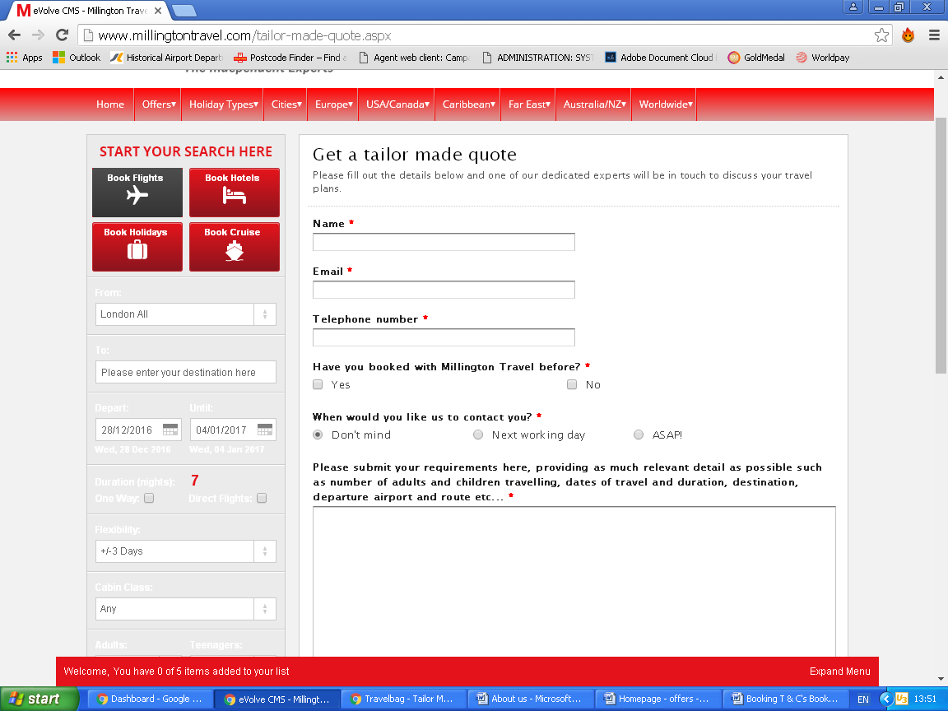Online Enquiry form

Here’s an example, please use this and adapt to website style